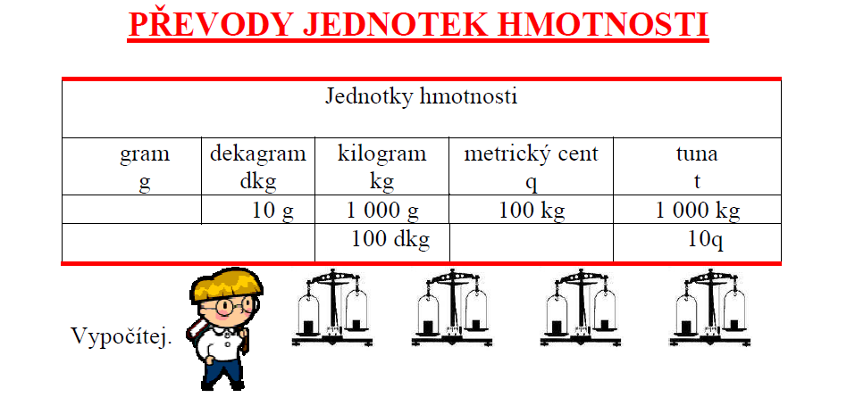
4 kg = g | 8 t = kg | 81q = kg
9 000 g = kg | 3 000kg = t | 60 g = dkg
15 kg = g | 71 t = kg | 47 kg = dkg
17 000 g = kg | 5 900 kg = t kg | 63 t = q

65 kg = g | 9 t = kg | 65q = kg
7 000 g = kg | 58 dkg = g | 53 t = q
15 kg = g | 500 dkg = kg | 2 t 54 kg = kg
170 g = dkg | 303 kg = dkg | 300 q = t

Doplň do 1 kg.
350 g + = 1 kg | 430 g + = 1kg
170 g + = 1 kg | 260 g + = 1kg
810 g + = 1 kg | 690 g + = 1kg
520 g + = 1 kg | 740g + = 1kg

V pizzerii Laguna nabízí pizzu. Je její hmotnost 1kg, pokud má všechny ingredience z receptu?
 | hmotnost
pizza korpus | 300 g
šunka | 120 g
slanina | 100 g
ementál | 30 g
niva | 150 g
žampiony | 100 g
kečup | 50 g
hmotnost celkem:

Odpověď:
_______________________________________________________________________________

